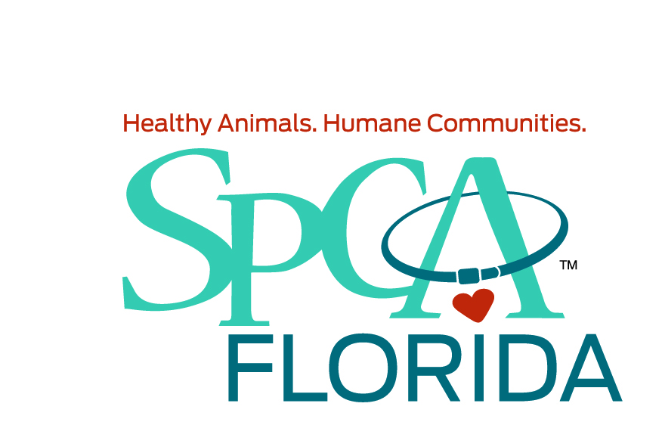

Here at SPCA Florida, our strength is our staff. We know that caring for animals is more than just a job, it's our passion. We have a team of dedicated, innovative, and compassionate people who work tirelessly to care for every animal that comes to our Adoption Center. We work together every day to make a difference in the lives of animals. SPCA Florida is seeking a full time experienced veterinary technician, to join our busy and growing adoption center. We are seeking caring, enthusiastic, skilled technicians to join our team and make a difference in the lives of our animals. If you are a veterinary technician who enjoys shelter medicine and working with a dynamic team to save lives, submit your resume.
SPCA Florida is a no kill, nonprofit, serving the community for forty-one years.

Knowledge, Skills, Abilities and Experience Required:
- Must Love Animals and Care about People.
- Preferred but not required: CVT Graduate from AVMA accredited program and/or equivalent experience as a veterinary assistant/technician.
- Proficient with humane restraint techniques in different situations and for various procedures, having the ability to administer medications, blood draws and I V Catheterization, take radiographs and proper positioning, have the ability to complete clinical laboratory tests, assist in surgery and perform dental procedures.
- Proficient in humane restraint techniques in different situations and for various procedures.
- Having the ability to administer medications, blood draws and I V Catheterization.
- Experience working as a veterinary technician in an established practice, preferably a shelter environment.
- Must be able to work a flexible schedule (including some Saturdays and Sundays as needed). We are open 7 days a week.
- Reliable transportation, valid driver’s license and proof of insurance
- Knowledge of Avimark and PetPoint a plus.
- Excellent interpersonal skills; attention to detail.
- Ability to work in an ever-changing environment
- Candidates must be eager to learn, show initiative, understand vaccine and product protocols, and ability to work in a very fast paced environment with minor supervision.
- As a benefit, the CVA online program is offered at no cost to the team member
- Reliable transportation, valid driver’s license and proof of insurance a must.

.
SPCA Florida offers competitive wages, benefits, a 403(b) plan, paid time off, and six (6) paid holidays. As an added benefit, SPCA Florida pays for CVA online program if not a CVT.
We offer very competitive salaries and an invigorating work environment with lots of room for career growth. We believe in a work/life balance to have a happy home life. These position allows you to participate in our excellent benefits package which includes paid time off, 401K, health, dental and vision insurance, and pet care discounts, At SPCA Florida we have created what we believe is a good balance between professional expertise and a positive work environment.

We are an Equal Opportunity Employer and Drug-Free Workplace; background checks

