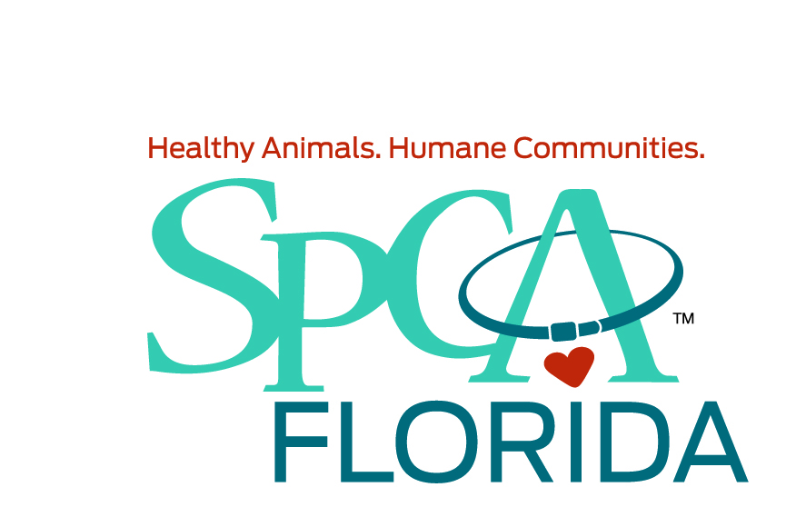

SPCA Florida is seeking a full time experienced veterinary technician, to join our busy and growing adoption center. Applicants should be proficient with humane restraint techniques in different situations and for various procedures, having the ability to administer medications, blood draws and I V Catheterization, surgical prep, monitoring hospitalized patients, filling Rx’s, fluid therapy. We practice high quality medicine with an amazing support staff and a positive work environment. We are seeking caring, enthusiastic, skilled technicians to join our team and make a difference in the lives of our animals. If you are a veterinary technician who enjoys shelter medicine and helping homeless animals, please submit your resume.

Knowledge, Skills, Abilities and Experience Required:
- 2-5 years’ experience working as a veterinary technician in an established practice, preferably a shelter environment.
- An equivalent combination of education and experience that is determined to be directly related to the specific requirements may be substituted.
- Must be able to successfully restrain animals, communicate clearly with clients, complete clinical laboratory tests, use multiple radiology techniques, administer and monitor animals under anesthesia, assist in surgery, and perform dental procedures.
- Must be able to work a flexible schedule (including Saturdays and Sundays). We are open 7 days a week; Five 8 hr days to facilitate the adoption center needs.
- Proficiency with Avimark and PetPoint a plus.
- Excellent interpersonal skills; attention to detail.
- Ability to work in an ever-changing environment
- Candidates must be eager to learn, show initiative, possess great customer service skills, have an understanding of vaccine and product protocols, knowledge of pet insurance, and ability to work in a very fast paced environment with minor supervision.
- Reliable transportation, valid driver’s license and proof of insurance a must.
- Nonsmoking campus, therefore, smoking is not allowed on campus.

Education:
- Preferred: CVT Graduate from AVMA accredited program and/or equivalent experience as a veterinary assistant/technician. Surgical experience required. Knowledge of PetPoint a plus

SPCA Florida offers competitive wages, benefits, a 403(b) plan, paid time off and six (6) paid holidays.

If you are looking for a career in animal welfare and want to make a difference, we want you!
Please submit resume with cover letter if this is you to www.spcaflorida.org.

We are an Equal Opportunity Employer and Drug-Free Workplace. Background checks and drug testing are required.

