***Florida Disaster Preparedness and Training Seminar…***

*Join us for an in-depth seminar on the complex issues associated with Disasters from a Florida perspective.*

**Friday, August 30, 2019**

**Humane Society of Vero Beach & Indian River County, FL**

**6230 77th Street**

**Vero Beach, FL 32967**

**9:00 AM Continental Breakfast**

**9:30 AM to 4:30 PM**

**Lunch included**

***A free seminar…***

*sponsored by the* ***Florida Association of Animal Welfare Organizations***

*hosted by the* ***Humane Society of Vero Beach & Indian River County, FL.***

**Limited Registration opens: July 30, on the FAAWO website** [**http://www.faawo.org/events**](http://www.faawo.org/events)

The Seminar will encompass the impact of disasters unique to Florida; including hurricanes, fires, tornadoes, floods a manmade – chemical, nuclear plant highway, and bio chemical events. Learn from our presenters with over 60 years of combined experience with disaster preparedness and response.

**Topics include**…

**Community Planning and Response**

* 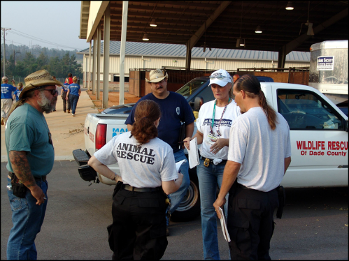Ensure your organization is recognized by your local government’s EOC as a partner in planning and response to disasters. Learn the role of Incident Command with Federal, State and Local government and how nonprofit agencies play have a vital role with disaster preparedness and response.
* Identifying community partners – collaboration
* Consider demographics – high risk pet owners
* Managing response - mash units, movement of animals and outside groups

“**If You Go, They Go”**

* 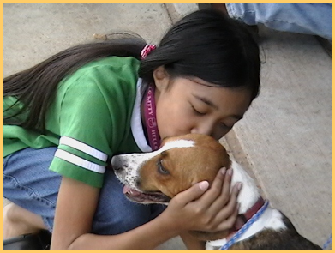Empower your pet owning community to take proactive steps to ensure their pets’

safety while sheltering in place or during

* 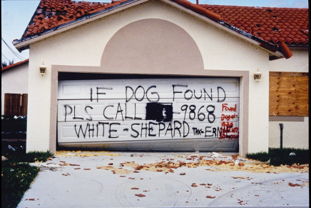Evacuation. Includes plans for dogs, cats, exotics,

equine and livestock

* Managing lost pet recovery during and after a

disaster

* Evacuation – determine route and destination
* Pet Friendly Sheltering
* Housing pets of special needs owners and emergency workers
* Modifying Foster programs to assist the pets of families impacted by disaster
* Disaster Planning for Horse and Livestock

**Continued**

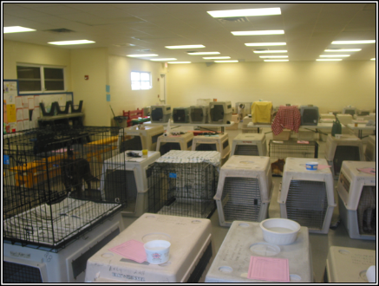**Shelter Planning**

* How to assess your housing capacity and structural integrity
* Learn internal incident command for shelter ops and staff/volunteer training
* Preplan sufficient inventory of food, medical and cleaning supplies, and alternate source of potable water
* Find partner agencies located outside the area of impact to transport adoption population before an event

**For transport…**

* Ensure best practices for transport and include multiple forms of Identification
* Lost and found both pre and post – how to determine holding times

Continued

**Seminar Presenters**

**Laura Bevan**

**Director, Southeast Region**

**The Humane Society of the United States**

Laura Bevan has worked for The Humane Society of the United States (The HSUS) since 1987. She is known for her extensive experience in working natural disasters, starting with Hurricane Andrew in 1992. She has since responded and helped direct animal relief efforts in numerous hurricanes, wildfires and floods. In 2004, Laura coordinated companion animal response efforts for the state during the four storms that hit Florida within a six-week period. In 2005, she was team leader for the HSUS’ Hurricane Katrina response in Mississippi. In 2018, she coordinated companion animal response for Hurricane Michael through the Florida State Agricultural Response Team (SART).

Laura served on an ad hoc committee that developed Florida's disaster plan for animals and was on the national committee that wrote the Federal Emergency Management Agency’s handbooks on disaster planning for animals. She wrote the HSUS Disaster Planning Manual, and the now retired HSUS disaster response and emergency sheltering trainings. Currently, Laura is an advisory board member for Florida SART, and an instructor for the Florida State Animal Response Coalition (SARC).

Laura has spoken at state and national emergency management conferences on disaster planning and response for animals. In 2008, Laura was honored as Humanitarian of the Year at the Florida Governor’s Hurricane Conference for her work developing and promoting disaster planning for animals. In 2019, she was recognized for her work in Florida’s animal disaster planning efforts at the Florida SART conference.

**Heather Thomas,**

**Executive Director**

**Humane Society of North Central Florida, Gainesville**

Heather Thomas is the Executive Director of the Humane Society of North Central Florida in Gainesville, FL. In 2018, Heather successfully led the Alachua County Humane Society, Gainesville Pet Rescue and Helping Hands Pet Rescue as they joined forces to become North Central Florida’s leading resource for pets and pet owners. The Humane Society is a member of the Alachua County coalition of animal rescue groups seeking to achieve a sustainable 90% live release rate in our community. The coalition has decreased euthanasia in Alachua County by over 90% since 2000 and achieved no kill status in 2017 and 2018 thanks to the group’s partnership, planning and patience.

Heather has served as Executive Director since 2010 and has worked in animal welfare for over 9 years. Heather’s expertise is in coalition building, collaboration, optimization of resources, strategic organizational development and mergers. Under Heather’s leadership, the Humane Society of North Central Florida has gained national notoriety for its hurricane response and relief efforts after Hurricane Irma in 2017 and Hurricane Michael in 2018. Heather is a proud pet parent and competitive equestrian.

**Etta LoPresti Emergency Management Coordinator**

**Indian River County Department of Emergency Services Emergency Management Division**

**Emergency Management Experience:** Have been with the Department since 1992

**Worked the following EOC activations in Indian River County:** Hurricane Andrew (1992),o Hurricane Erin (1995), Hurricane Floyd (1999), Y2K (Dec. 31/Jan. 1 – 1999/2000), Hurricane Frances (2004), Hurricane Jeanne (2004), Hurricane Wilma (2005), Tropical Storm Ernesto (2006), Hurricane Matthew (2016) ,Hurricane Irma (2017), Participant in numerous drills and exercises

**Memberships and Affiliations**:

* Local Emergency Planning Committee (Appointed)
* Florida Emergency Preparedness Association
* International Association of Emergency Managers
* Local Mitigation Strategy Working Group Vice Chair • Ham Radio operator KM4KTN

**Job Duties:** **Emergency Operations Center Ops Chief**

* Developed and maintain the county’s Comprehensive Emergency Management Plan
* Maintain the county’s Hazardous Materials Plan
* Provide public outreach presentations on disaster preparedness to groups such as: community service organizations, church groups, homeowner’s associations, members of the private sector, health care community, etc. • Initiated the emergency management accreditation process

**Special Accomplishments**:

* Awarded the Thomas Yatabe Certificate of Outstanding Achievement (2006)
* Coordinated implementation of Indian River County’s pet-friendly shelter
* Coordinated Indian River County’s Tsunami Preparedness Program (first county in the state of Florida to be designated by the NWS Tsunami Ready Program)

**Ilka Daniel**

**Director of Animal Protection Services**

**Humane Society of Vero Beach & Indian River County, FL**

While Ilka spent much of her youth on her parents’ Arabian horse farm in Bucks County, PA; she found her way to Vero Beach in the late ‘70’s where she worked with veterinarians specializing in the equine, companion animal, and exotics fields. She joined the Humane Society staff in 2000 as an Animal Cruelty Investigator and now directs our Animal Protection Services. Ilka’s first response was to Hurricane Andrew as a liaison between Indian River County Veterinarians and Veterinarians located within the path of destruction delivering supplies and her services. Currently Ilka serves as Co-Chair to IRC ESF#17 for the Humane Society of Vero Beach & Indian River County. She enjoys kayaking, hiking, gardening, and spending time with her grandchildren, who live in Sebastian.